

Student Name……………………………………

FURTHER MATHEMATICS

TRIAL EXAMINATION 2

2006

Reading Time: 15 minutes
Writing time: 90 minutes

Instructions to students
This exam consists of Section A and Section B.
Section A contains a set of extended answer questions from the core, 'Data Analysis'.
Section A is compulsory and is worth 15 marks.
Section B begins on page 8 and consists of 6 modules. You should choose 3 of these modules and answer every question in each of your chosen modules. Each of the modules is worth 15 marks.
There is a total of 60 marks available for this exam.
The marks allocated to each of the four questions are indicated throughout.
Students may bring one bound reference or one text that may be annotated or one lecture pad into the exam.
A graphics or CAS calculator may be used in the exam.
Formula sheets can be found on pages 32-33 of this exam.
Unless otherwise stated the diagrams in this exam are not drawn to scale.

This paper has been prepared independently of the Victorian Curriculum and Assessment Authority to provide additional exam preparation for students. Although references have been reproduced with permission of the Victorian Curriculum and Assessment Authority, the publication is in no way connected with or endorsed by the Victorian Curriculum and Assessment Authority.

© THE HEFFERNAN GROUP 2006
This Trial Exam is licensed on a non transferable basis to the purchaser. It may be copied for educational use within the school which has purchased it. This license does not permit distribution or copying of this Trial Exam outside that school or by any individual purchaser.

Section A - Core

This section is compulsory.

Question 1

Ten Year 11 students were asked to estimate their average travelling time to and from school each day.
Their responses are given in Table 1 below.

Travelling time (mins) | 5 | 12 | 18 | 27 | 45 | 46 | 50 | 62 | 70 | 73
Table 1

- Calculate the mean and the standard deviation for this set of data.
Express your answers correct to two decimal places where appropriate.

mean = standard deviation =

2 marks

These ten students were also asked to estimate the average amount of time they spent doing homework on a weeknight.

A scatterplot of the average daily homework time against the average daily travelling time for each of the ten students is shown in Diagram 1 below. A least squares regression line has been fitted to the data. The scale on the average daily homework time axis has been omitted.

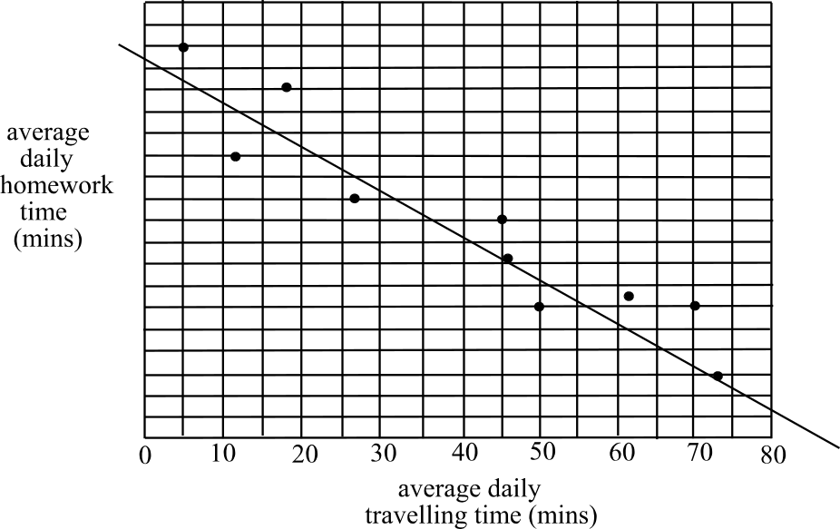

Diagram 1

- Looking at the scatterplot in Diagram 1, it appears that as travelling time increases,

homework time and therefore the sign of r; Pearson’s product-moment

correlation coefficient, would be .

2 marks

- The percentage of variation in the homework time that can be accounted for by the variation in travelling time is 89.27%.

Using this fact together with your response to part b. the value of r (Pearson’s

product-moment correlation coefficient) is . Express your answer correct to two decimal places.
1 mark

- A least squares regression line of the form 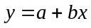 is to be calculated for the data using the formulae 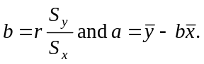
Given that 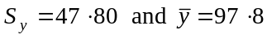, and using your answers to parts a. and c. find the equation of the least squares regression line. Express each value correct to 2 decimal places.

average daily homework time = + average daily travelling time

2 marks

Question 2

A sample of ten Year 10 students were similarly asked to estimate their average daily travelling time to and from school together with their average daily time spent doing homework.

Their responses are given in Table 2 below.

Travelling time (mins)  (x) | 10 | 15 | 17 | 23 | 30 | 35 | 40 | 42 | 45 | 48
Homework time (mins)  (y) | 70 | 75 | 85 | 80 | 78 | 69 | 62 | 45 | 30 | 25
Table 2

A scatterplot of this data is shown in Diagram 2 below.

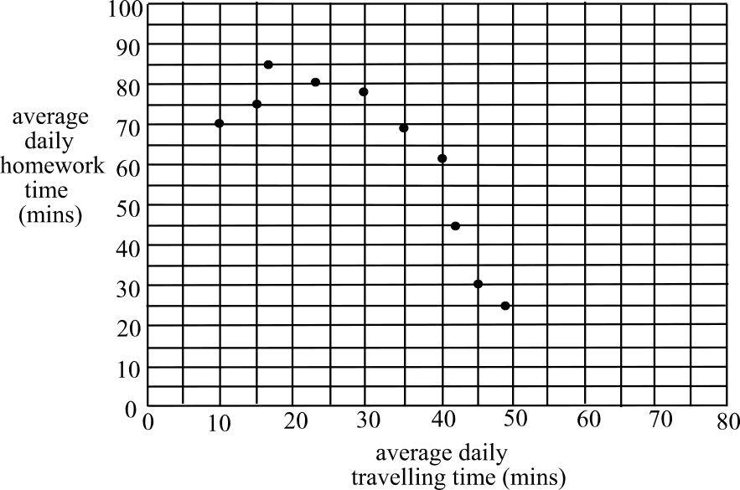

Diagram 2

A least squares equation was calculated for this data and was given by
average daily .

A residual plot for the data is shown in Diagram 3 below.

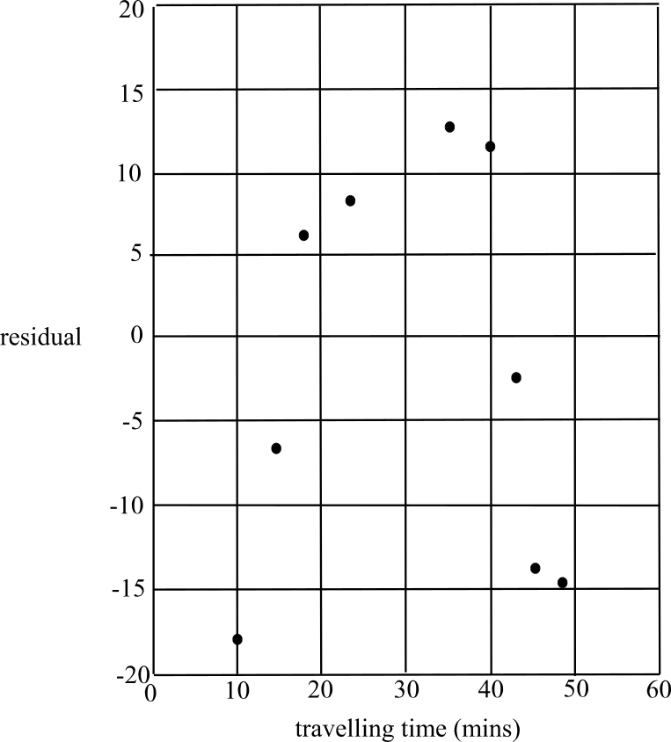

Diagram 3

- Using the information in Table 2 complete the residual plot in Diagram 3 by filling in the missing point that relates to the student with a travelling time of thirty minutes.

1 mark

- What aspect of the points plotted on the residual plot, in Diagram 3, suggest that a transformation is required to linearise the original data?

1 mark
A transformation where each of the values on the horizontal, (travelling time) axis is squared, is to be used in an attempt to linearise the data.
Table 2 has been reproduced with an extra line for the transformed variable. The table is not complete and is shown as Table 3 below.

Travelling time | 10 | 15 | 17 | 23 | 30 | 35 | 40 | 42 | 45 | 48
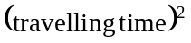 | 100 | 225 | 289 | 529 | 900 | 1225 | 1600 | 1764 | 2025
Homework time | 70 | 75 | 85 | 80 | 78 | 69 | 62 | 45 | 30 | 25
Table 3

- Complete Table 3 above by filling in the entry in the shaded cell.

1 mark

- In an attempt to linearise the data, what other transformation might reasonably have been used. Explain clearly which axis you would apply the transformation to.

1 mark

A scatterplot of average daily homework time (y) plotted against average daily travelling time squared, is shown in Diagram 4 below.

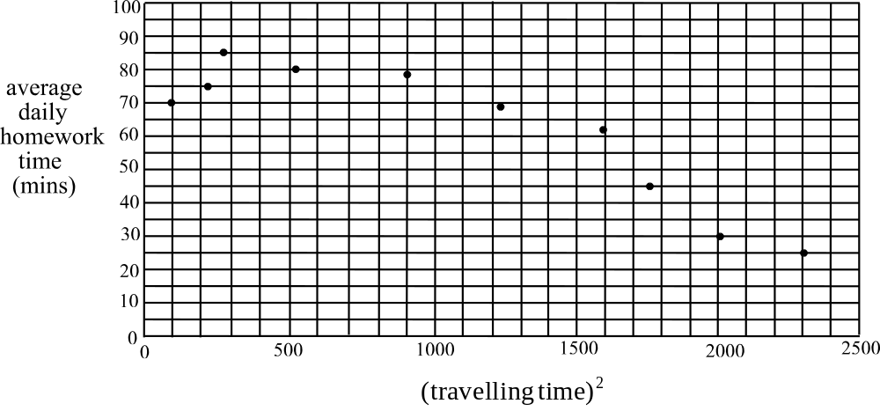

Diagram 4

- Using Table 3, find the least squares regression line for average daily homework time against . Express each value correct to two decimal places.

average daily homework time = + (average daily travelling time)

2 marks

- To test whether this transformation has been successful in linearising the data

  - what should now be constructed?

  - what feature should be present if the transformation has been successful?

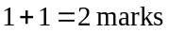
Total 15 marks

Section B

Module 1: Number patterns

If you choose this module all questions must be answered.

Question 1

A call centre is being set up. The proposed number of calls made from the call centre follows an increasing geometric sequence. The proposed number of calls made during each of the first three weeks of operation is shown in Table 1.

Week | 1 | 2 | 3
Number of calls | 6 000 | 7 200 | 8 640
Table 1

- Show that the common ratio, r, of the geometric sequence is 1.2.

1 mark

- During which week of operation would the number of calls made first exceed 50 000?

1 mark

- How many calls would be made during the first twenty weeks of operation? Express your answer to the nearest whole number.

1 mark

- A difference equation that generates this geometric sequence is of the form

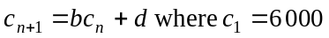.

Find the values of b and d.

b = d = 2 marks

Question 2

When the call centre actually opened, the number of calls; 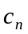, made in the 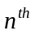 week of its operation, was closely modelled by the difference equation

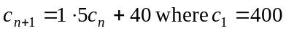

The table below shows the first three terms of the sequence generated by this difference equation.

Week | 1 | 2 | 3 | 4
Number of calls | 400 | 640 | 1 000

- Complete the table by filling in the shaded cell.

1 mark

- State whether the sequence is arithmetic, geometric or neither. Give reasons for your answer.

3 marks

- According to this model what is the increase in the number of calls made from the call centre between weeks ten and eleven? Express your answer to the nearest whole number.

2 marks

Question 3

To recruit operators quickly at the call centre, a bonus plan is devised. According to this bonus plan, an operator would receive a large financial bonus by recruiting two new people each week.
In the week following recruitment, the new people would undergo training and in the week following that, they would begin working in the call centre as operators.
If this plan was successful, the number of people working as operators n weeks after the centre opened would be given by 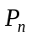where

- Assuming that the plan was successful find the number of operators who would be working in the call centre in the third week after the call centre opened.

1 mark

- Find the number of operators who would be working in the call centre in the fifteenth week of its operation.

2 marks

- If there is capacity for only fifteen hundred operators in the call centre, during which week would they need to stop this method of recruiting operators?

1 mark
Total 15 marks

Module 2: Geometry and trigonometry

If you choose this module all questions must be answered.

Question 1
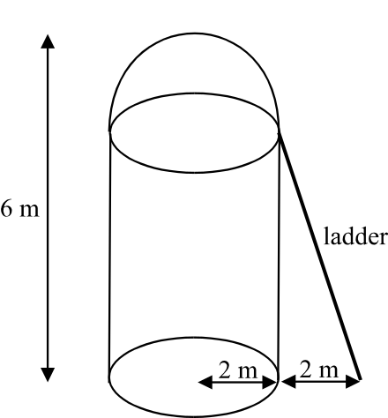

A water tank is in the shape of a cylinder with a hemispherical top. A ladder leans against the tank in such a way that the top of the ladder meets the tank where its hemispherical top joins its vertical sides. The base of the ladder rests on horizontal ground two metres from the base of the water tank.

a. Find the length of the ladder. Express your answer correct to 2 decimal places.

____________________________________________________________________

____________________________________________________________________

____________________________________________________________________
1 mark

b. Find the surface area (including the base) of the water tank. Express your answer correct to 2 decimal places.

____________________________________________________________________

____________________________________________________________________

____________________________________________________________________

____________________________________________________________________
2 marks

c. Find the volume of the water tank in cubic metres. Express your answer correct to 2 decimal places.

____________________________________________________________________

____________________________________________________________________

____________________________________________________________________
1 mark
Question 2

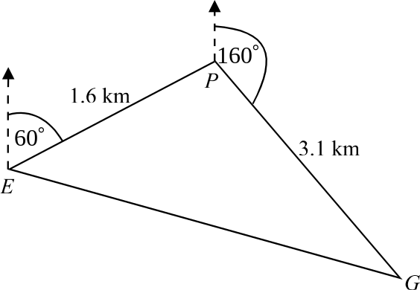

The water tank is located at a picnic ground in a national park.
From the entrance gate at point E of the national park, the picnic ground P is situated 1.6km away on a bearing of 060°. The exit gate at G is situated 3.1km from P on a bearing of 160°.

- i. How far north of the entrance gate at E is the picnic ground at P?

  - How far north of the exit gate at G is the entrance gate at E?
Express your answer correct to 2 decimal places.

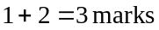

- i. Find the angle EPG.

- Find the area enclosed by the triangle EPG. Express your answer correct to 2 decimal places.

- Find the length of EG. Express your answer correct to 2 decimal places.

1 mark

- Calculate the bearing of the exit gate at G from the entrance gate at E. Express your bearing to the nearest whole degree.

2 marks

Question 3

In the picnic ground, on flat ground, is a vertical pole BP of height 6m that was used in a ropes course.
The pole is anchored to the ground at points A and C by two taut guy ropes.
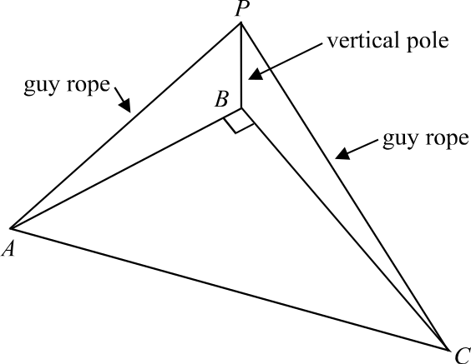

The guy rope indicated by AP is 16m long and the guy rope indicated by CP is 21m long.
Find the distance AC.

3 marks
Total 15 marks

Module 3: Graphs and relations

If you choose this module all questions must be answered.

Question 1

Arnold runs two cafes; Café Arnold and Café Arnie both of which offer eat-in meals and take-home meals. Café Arnold sells on average, per hour, 50 eat-in meals and 40 take-home meals. Café Arnie sells on average, per hour, 30 eat-in meals and 60 take-home meals. Arnold needs to sell at least 1500 eat-in meals per week and 1560 take-home meals per week.
Let x = the number of hours Café Arnold is open per week.
Let y = the number of hours Café Arnie is open per week.
The inequations that arise from this information are:

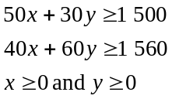

The boundaries formed by the first two inequations are shown as lines on the graph below.

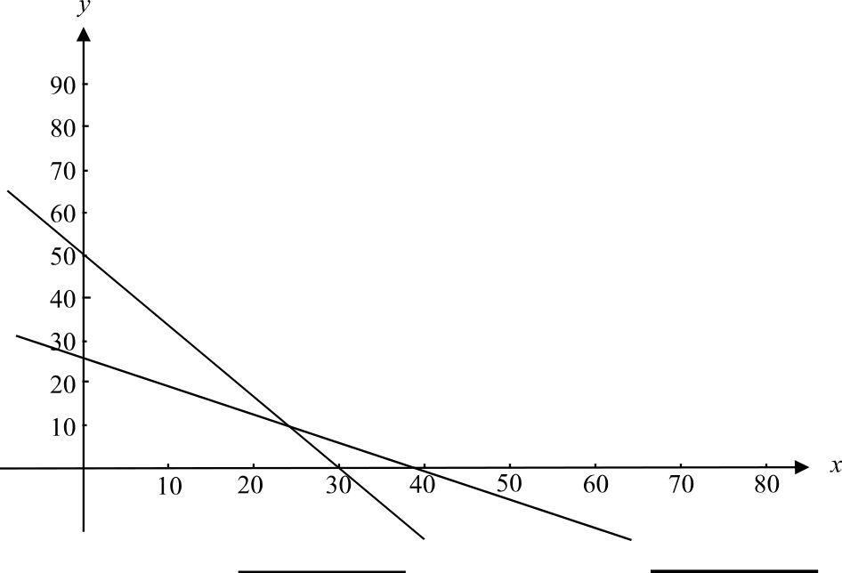

- On the graph above, in the spaces provided, write the equation of each line.
1 mark

- Find the x-intercept of the line with equation 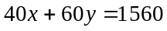.

1 mark
- Find the coordinates of the point of intersection of the two lines shown on the graph.

2 marks

Because of staffing issues Café Arnold can stay open for up to 80 hours per week and Café Arnie for up to 50 hours per week.

- Write down the two inequalities that arise from this information.

1 mark

- On the set of axes below, using these two inequalities, show the feasible region for the hours of operation of the two cafes for a week.
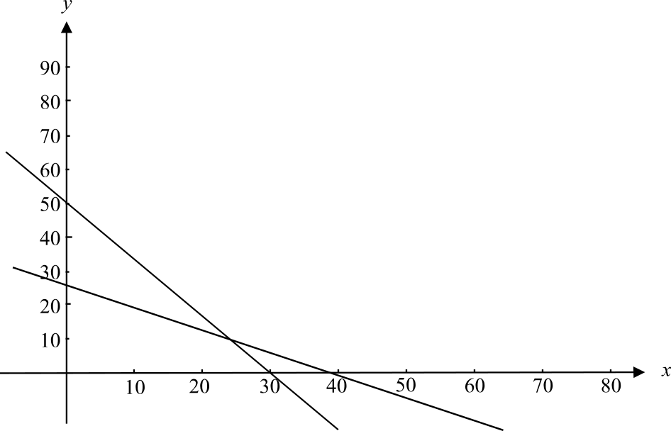

3 marks

The cost of operating Café Arnold per hour is $430 and the cost of operating Café Arnie per hour is $380.

- Write down an expression for C in terms of x and y where C is the cost of operating the two cafes for a week.

1 mark

- What is the minimum cost of operating the two cafes per week?

2 marks

Question 2

The distance between Café Arnold and Café Arnie is 5km. Each day Arnold tries to cycle one way between the two. The distance-time graph for one such ride from Café Arnold to Café Arnie is shown below.
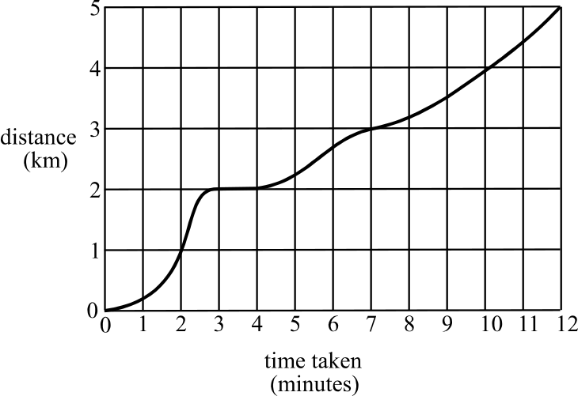

- Explain whether or not Arnold was stationary on his bike during the ride and if so, when and for approximately how long was he stationary?

1 mark
- Estimate when Arnold was riding fastest during his ride.

1 mark

- How far is Arnold from Café Arnie nine minutes into the ride?

1 mark

- What is the average rate of change of distance with respect to time between 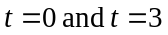.

1 mark
Total 15 marks

Module 4: Business-related mathematics

If you choose this module all questions must be answered.

Question 1

The price of a plasma-screen television is $5 200 and this includes 10% GST (Goods and services tax).

- What was the price of the television before the GST was applied? Express your answer correct to the nearest cent.

1 mark

- Ray pays twenty-four monthly instalments of $240 to the store to purchase the television.

- How much does he pay in total for the television?

- How much of this is interest?

- i. What annual simple rate of interest is Ray being charged by the store? Express your answer as a percentage correct to 2 decimal places.

- What is the effective rate of interest per annum. Express your answer as a percentage correct to 2 decimal places.

Question 2

Ray plans to put the television in the boardroom of his business office. He has two options to depreciate the value of the television.

- Ray’s first option is to depreciate the value of the television each year over four years by a flat rate of 16% of the original cost of the television.
What would the depreciated value of the television be after four years using this method?

1 mark

- Ray’s second option is to depreciate the value of the television over four years at the rate of 18% per annum.
What would the depreciated value of the TV be after four years using this method? Express your answer to the nearest cent.

2 marks

Question 3

Ray is about to retire and he will receive a superannuation payment of $380 000.
One of Ray’s options is to invest this money in an annuity, which is invested at 6% per annum interest, compounded monthly.

He needs to receive a monthly payment of $2 500 to live on.

- How long will Ray’s annuity last? Express your answer in years correct to 1 decimal place.

2 marks

- If Ray wanted his annuity to last for 30 years, what monthly payment would he receive?

2 marks

Another of Ray’s options is to purchase a perpetuity.

- If Ray were to invest his $380 000 in a perpetuity which is invested at 6% per annum compound interest calculated monthly what would be the monthly payments made to Ray?

1 mark

- What amount would Ray need to invest in this perpetuity in order to receive a monthly payment of $2500?

1 mark

- What major advantage does a perpetuity have over an annuity?

1 mark
Total 15 marks

Module 5: Networks and decision mathematics

If you choose this module all questions must be answered.

Question 1

The network below shows the distances, in metres, along a series of access roads in a large caravan park by the sea.
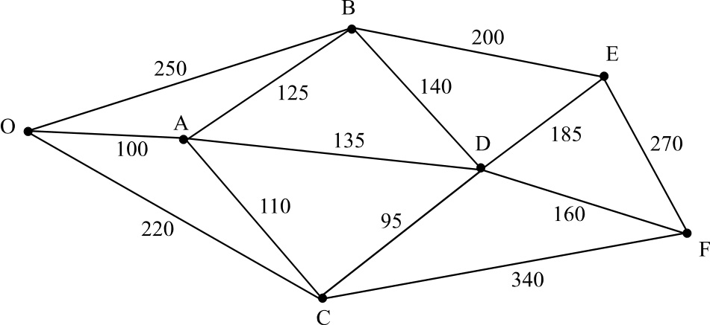

The access roads connect the office at O and the amenities blocks that are located at A, B, C, D, E and F.

- What is the length of the shortest path between the office and the amenities block at F?

1 mark

A truck that collects rubbish starts each morning at the office and drives along a route through the caravan park that can be described as a Hamiltonian circuit.

- Write down a sequence of letters that could describe the route taken by the truck.

1 mark

- i Explain why it is not possible for the rubbish truck to complete an Euler circuit in the caravan park.

- In order that the rubbish truck can complete an Euler circuit in the caravan park starting at the office, two new roads need to be added to the network. Give details of two such roads that could be added.

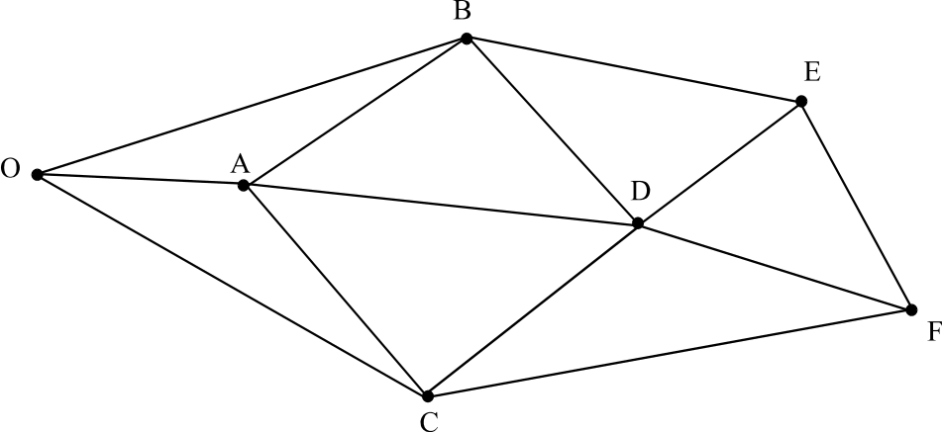

1 + 1 = 2 marks

Question 2

Over the years the management at the caravan park have employed four different maintenance companies, M, N, O and P to maintain amenity blocks A, B, C and D.
The table below shows the annual cost in dollars of maintaining each of the blocks by each of the companies.

 | A | B | C | D
M | 900 | 800 | 700 | 600
N | 750 | 550 | 850 | 850
O | 950 | 800 | 800 | 650
P | 900 | 900 | 850 | 900

Management would like to allocate one amenity block to one maintenance company in such a way that the annual cost of maintaining the four blocks is a minimum.

- Use the Hungarian algorithm to find the allocation that achieves management’s goal.

3 marks

- What is the total annual cost for this allocation?

1 mark
Question 3

Construction of a new amenities block is to take place over the winter.

The network diagram below shows the activities, A-K, required to complete the construction and the time, in weeks, needed to complete each of them.
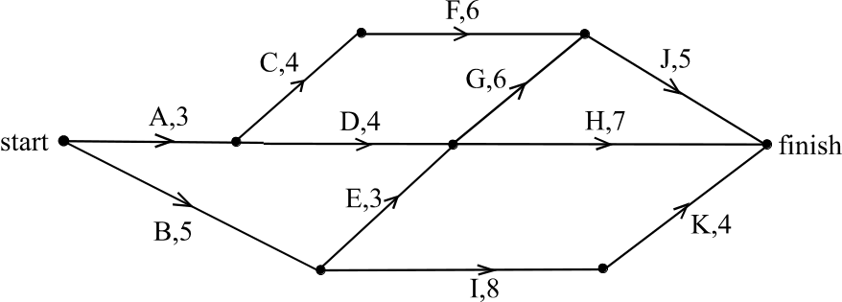

The table below shows the earliest and latest start times for each activity together with the immediate predecessor of each activity.
Two of the entries in the table are missing.

Activity | Immediate Predecessor(s) | Duration  (weeks) | Earliest start time | Latest start time
A | - | 3 | 0
B | - | 5 | 0 | 0
C | A | 4 | 3 | 4
D | A | 4 | 3 | 4
E | B | 3 | 5 | 5
F | C | 6 | 7 | 8
G | D, E | 6 | 8 | 8
H | D, E | 7 |  | 12
I | B | 8 | 5 | 7
J | F, G | 5 | 14 | 14
K | I | 4 | 13 | 15

- Complete the two missing entries in the shaded cells of the table above.

2 marks

- What is the minimum amount of time required to construct the amenities block?

1 mark

- Which activity can be delayed the longest without delaying the completion date?

1 mark
- To reduce the time taken to construct the amenities block, the builder is able to, at a cost, reduce the duration of activity G to five weeks.

- Use the network below to decide which activities cannot now be delayed if this new completion time is to be achieved.

- Explain why it is not cost effective to reduce activity G to 4 weeks.

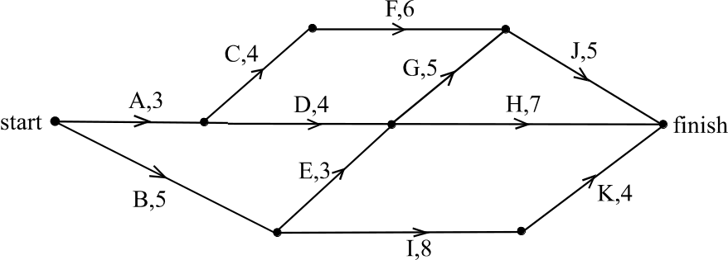

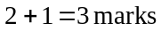
Total 15 marks
Module 6: Matrices

If you choose this module all questions must be answered.

Question 1

A local council operates three libraries. The number of books a, b and c, borrowed in December 2005 from the three libraries located respectively at Alphinghurst, Broadlake and Casaville can be determined from the matrix equation below.

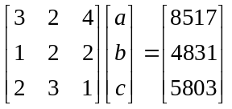

- Express this matrix equation as a system of three simultaneous linear equations.
(Do not attempt to solve the system of equations.)

1 mark

- Explain whether or not it is possible to complete the following matrix multiplication.
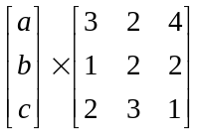

1 mark

- For the square matrix 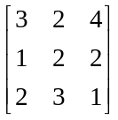 find

- its determinant.

- its inverse.

- Find the number of books borrowed in December 2005 from each of the three libraries by solving the matrix equation
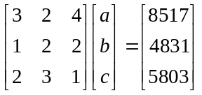

2 marks

Question 2

Ratepayers can borrow books from any of the three libraries for up to a month and may return the books to any of the three libraries.

Over the last few years, it has been found that:
- 65% of books borrowed from library A are returned to library A
- 15% of books borrowed from library A are returned to library B
- 20% of books borrowed from library A are returned to library C

- 9% of books borrowed from library B are returned to library A
- 82% of books borrowed from library B are returned to library B
- 9% of books borrowed from library B are returned to library C

- 11% of books borrowed from library C are returned to library A
- 15% of books borrowed from library C are returned to library B
- 74% of books borrowed from library C are returned to library C

where library A refers to the library at Alphinghurst, library B refers to the library at Broadlake and library C refers to the library at Casaville.

- Complete the transition matrix T below using the information above and expressing percentages as decimals.

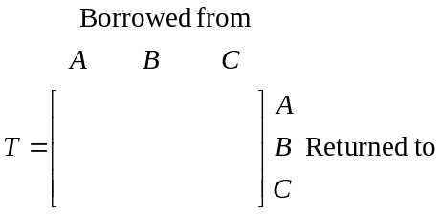

2 marks

At the start of 2006 the librarians at the three libraries made available for loan 80 new books with large print. They decided that initially, 35 of these books would be located at Alphinghurst, 25 would be located at Broadlake and 20 would be located at Casaville.
Such is the demand for these books, that it can be assumed that they are always out on loan and always for the maximum period of one month.

- Construct a matrix of order 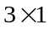, labelled 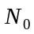, that describes the number of these new books with large print that are initially located at Alphinghurst, Broadlake and Casaville respectively.

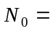

1 mark

- Using the matrices T and , find the number of these large print books that are located at the three libraries one month after they are made available for loan. Express your answers to the nearest whole number.

2 marks

- Find the number of these large print books that would be located at each of the three libraries at the start of 2007. Express your answer to the nearest whole number.

1 mark

- One of the librarians at Alphinghurst is concerned that there will eventually be only about half of these large print books originally allocated to his library, still located there. Assuming that the pattern of borrowing and returning outlined earlier is to continue, explain whether or not the librarian’s concern is correct.

3 marks
Total 15 marks
Further Mathematics Formulas

Core: Data analysis

standardised score: 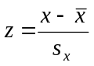
least squares line: 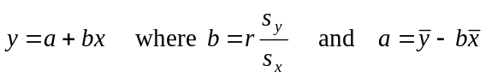
residual value: residual value = actual value – predicted value

seasonal index: seasonal index 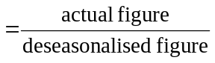

Module 1: Number patterns

arithmetic series: 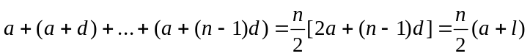
geometric series: 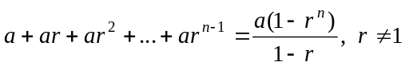
infinite geometric series: 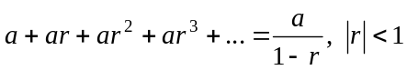

Module 2: Geometry and trigonometry

area of a triangle: 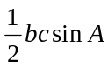
Heron's formula: 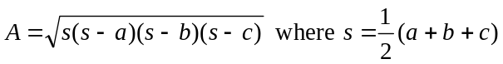
circumference of a circle: 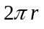

area of a circle: 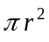

volume of a sphere: 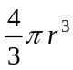
surface area of a sphere: 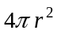

volume of a cone: 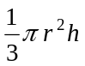
volume of a cylinder: 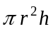

volume of a prism: 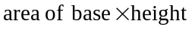
volume of a pyramid: 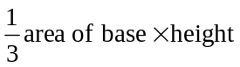

Reproduced with permission of the Victorian Curriculum and Assessment Authority, Victoria, Australia.
These formula sheets have been copied in 2006 from the VCAA website www.vcaa.vic.edu.au
The VCAA publish an exam issue supplement to the VCAA bulletin.
Pythagoras’ theorem 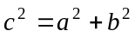

sine rule: 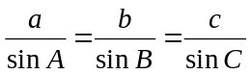
cosine rule: 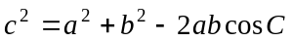

Module 3: Graphs and relations

Straight line graphs
gradient (slope): 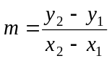
equation: 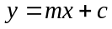

Module 4: Business-related mathematics

simple interest: 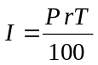
compound interest: 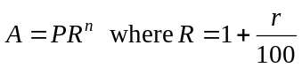
hire purchase: 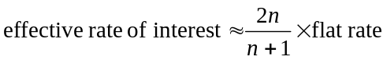

Module 5: Networks and decision mathematics

Euler’s formula: 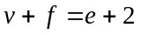

Module 6: Matrices

determinant of a 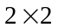 matrix 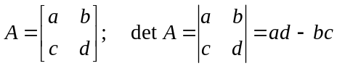
inverse of a matrix 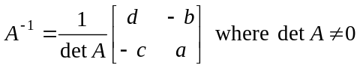

END OF FORMULA SHEET

Reproduced with permission of the Victorian Curriculum and Assessment Authority, Victoria, Australia.
These formula sheets have been copied in 2006 from the VCAA website www.vcaa.vic.edu.au
The VCAA publish an exam issue supplement to the VCAA bulletin.

